**IELTS Coaching in Chandigarh**

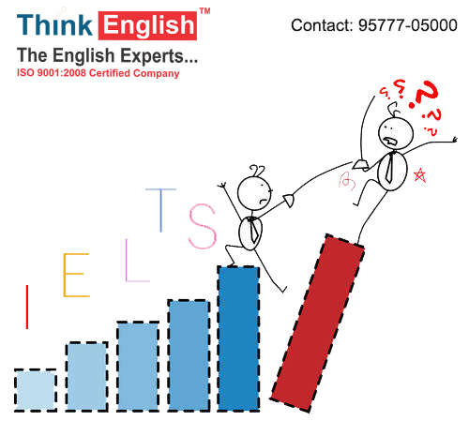

**Looking For NO.1**

**IELTS Coaching Institute In Chandigarh**

If you're searching for IELTS institute in Chandigarh then you're at right place. [**ThinkEnglish**](https://thinkenglish.in/) is a premier institution for IELTS classes in Chandigarh. We believe in bringing out the best in scholars. Module-specific training is also provided via IELTS training so that the students can hone their skills in a particular area also where they could lag behind. It's rightly stated that ‘practice makes a man perfect’, however along with practice in IELTS what one wishes is proper guidance, strategies and feedback’s, which we offer to the best of our capabilities.

### KNOW THE REASON

# WHY WE ARE THE BEST?

* Face to face English language and IELTS preparation classes.
* Top quality classes, friendly, helpful {and professional} staff.
* Only 3-5 students in one class with Versatile training on a regular basis.
* Free Extra Practice Material to take alongside and Technical & non technical embassy interview guidelines.
* Preparation of resume writing.
* Study from Highly Qualified & Experienced Faculty.
* Weekly Mock Test as per real exam pattern.
* Check your performance via Gantt chart.
* Making improvements to your vocabulary in a systematic manner.
* Working on the other weak areas such as sentence construction, grammar, overall clarity of the written English.
* Working to improve your general English skills to maximise your IELTS score.
* Covering all modules of the test day by day and helping you recognize the exam structure.
* Offering individualized strategies to maximise your IELTS score.

#### 

Top of Form

## MODULES WE PROVIDE

### LISTENING

You will listen to four different recordings and answer 40 questions. The test takes roughly 30 mins. You are going to have an extra ten mins to transfer your solutions to a solution sheet. You only hear the audio once. Various voices and native-speaker accents are used.

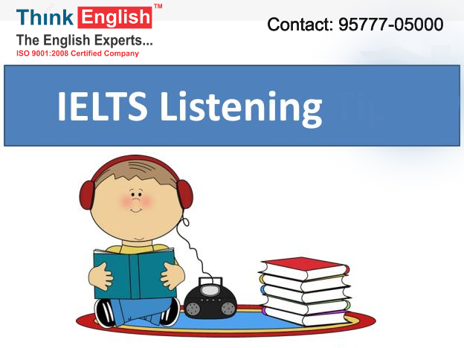

### SPEAKING

Within the Speaking test, you've a discussion with a certified Examiner. It's interactive and as close to a real-life scenario as a test can get. The test is 11 to 14 mins long with 3 parts.

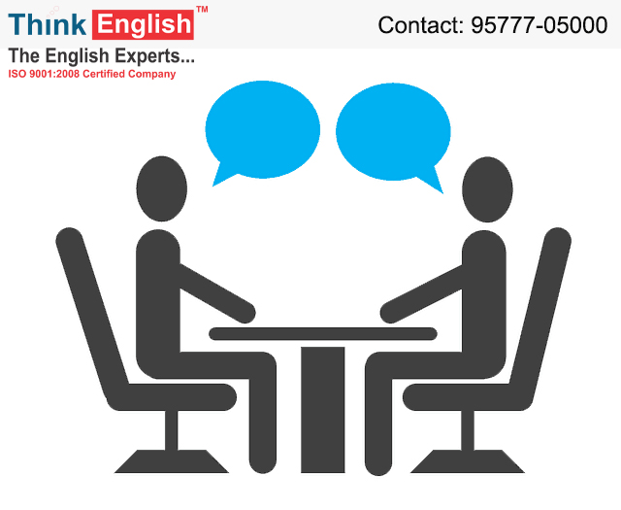

### WRITING

The writing component of the IELTS exam is designed to assess how you “write a response appropriately, organise ideas and use a range of vocabulary and grammar accurately.” It comprises two tasks and candidates have 60 minutes to answer them

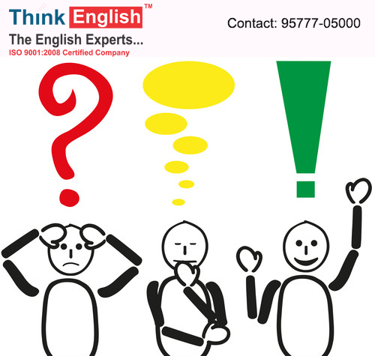

### READING

Reading is the second part of the IELTS test, and takes 60 mins. It is composed of 3 or sometimes 4 reading passages of increasing difficulty, and there's a total of 40 questions to answer. The Academic and General Training Reading Tests are graded to the same level.

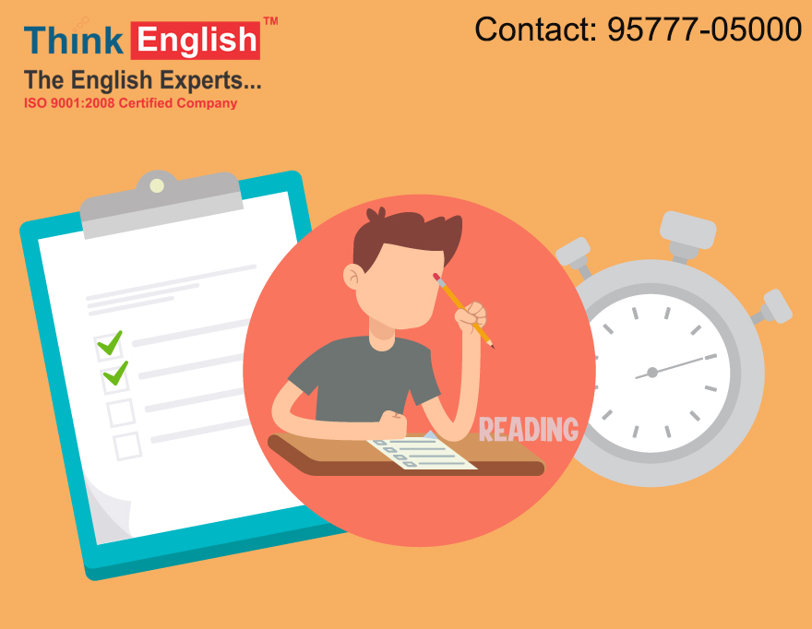

Bottom of Form